KWAME NKRUMAH UNIVERSITY OF SCIENCE AND TECHNOLOGY



FINAL YEAR PROJECT

Bsc. Computer Science

STUDENT ACADEMIA COPLIOT

BY:

ADU STEPHEN - 4187320

KESSEWAA ACHEAMPONG- 4184220

DR EMMANUEL AHENE

### DECLARATION

I declare without any reservation that we personally undertook this project, “STUDENT ACADEMIA COPILOT (**SAC AI)**” on KNUST campus, herein submitted under supervision.

Signed: Date:

_________A.S__________ _____3/09/24_______

ADU STEPHEN

(4187320)

Signed: Date:

__________K.A_________ ______3/09/24______

KESSEWAA ACHEAMPONG

(4184220)

DECLARATION BY SUPERVISOR

I declare that I have personally supervised these students in undertaking the study report herein and I confirm that these students have my permission to present it for assessment.

Signed: Date:

_________________ ___________________

DR EMMANUEL AHENE

(SUPERVISOR)

ACKNOWLEDGEMENT

We would first and foremost like to thank God Almighty for His unending grace towards us for the completion of this work. We are also sincerely grateful to Dr Emmanuel Ahene, our supervisor and a lecturer of Computer Science Department, Kwame Nkrumah University of Science and Technology for his immense support and guidance. We acknowledge him for always making time for us each and every time to meet us, his constant support, advice and encouragement throughout this project. We express our profound gratitude to you.

### DEDICATION

We dedicate this project to our supervisor Dr Emmanuel Ahene and our wonderful parents for their love and every inspiration they gave us. We dedicate this project also to the students of Kwame Nkrumah University of Science and Technology.

Table of Contents

DECLARATION 1

DECLARATION BY SUPERVISOR 2

ACKNOWLEDGEMENT 2

DEDICATION 3

Chapter 1: Introduction 6

1.1 Problem Statement 6

1.2 Aim of Project 6

1.3 Specific Objectives 7

1.4 Justification of Project 8

1.5 Motivation of Project 9

1.6 Scope of Project 10

1.7 Project Limitation 11

1.8 Beneficiaries of Project 13

1.9 Academic and Practical Relevance of the Project 15

1.10 Project Deliverables 17

Chapter 2: Review of Related Works / Review of Similar Systems 19

2.3 Conceptual Design 23

2.4 Architecture of the Proposed System 26

2.5 Components Designs and Components Descriptions 26

2.7 Development Tools and Environment 28

Chapter 3: Methodology 34

3.1 Chapter Overview 34

3.4 Functional Requirements 37

3.5 UML DIAGRAMS 39

3.5.2 Activity Diagram 42

3.5.3 Sequence Diagram 44

3.6 Non-Functional Requirements 45

3.8 Project Methods 47

Chapter 4: Implementation and Results 51

4.1 Chapter Overview 51

Chapter 5: FINDINGS AND CONCLUSION 55

5.8 References 63

# Chapter 1: Introduction

## 1.1 Problem Statement

Students today are inundated with information from a wide variety of sources, ranging from textbooks and academic journals to online articles and multimedia content. However, navigating and efficiently learning from these resources can be a daunting task. The challenge is further compounded when students need to extract meaningful insights or summaries from lengthy documents or complex web pages. Traditional study methods, which rely heavily on manual note-taking and self-summarization, are often inefficient and prone to errors. This lack of a centralized and intelligent tool to assist students in processing and understanding diverse forms of academic content results in fragmented learning experiences, reduced comprehension, and ultimately, diminished academic performance.

The "Student Academia Copilot" web application is designed to address these challenges by offering a comprehensive platform that enables students to learn from any document type or web page by simply providing a URL. This application aims to streamline the learning process by automatically analyzing, summarizing, and providing key insights from the provided content. By integrating advanced AI-driven features, the platform not only enhances comprehension but also saves students valuable time, allowing them to focus on applying their knowledge rather than merely gathering it. The user-friendly interface ensures that students can effortlessly navigate through the learning material, making the "Student Academia Copilot" an essential tool for academic success in the digital age.

## 1.2 Aim of Project

The aim of the "Student Academia Copilot" project is to develop an intelligent and user-friendly web application that empowers students to efficiently learn from any document type or web page by providing a URL. This application seeks to streamline the process of information extraction, comprehension, and application by leveraging advanced AI technologies to analyze, summarize, and present key insights from diverse academic resources. Ultimately, the project aspires to enhance students' learning experiences by providing them with a centralized platform that simplifies content navigation, improves understanding, and supports academic success across various subjects and disciplines.

## 1.3 Specific Objectives

The objectives of this project encompass designing an engaging user interface with Flutter, implementing precise timed practice tests, integrating secure Firebase authentication, creating a comprehensive feedback system, developing a scalable backend with Firebase, ensuring a smooth user experience, tracking test history, enabling test review functionality, optimizing performance, supporting multiple courses at KNUST, and conducting thorough testing and refinement.

* **Design and Craft a User Interface**:

Create an aesthetically pleasing and intuitive user interface using the Flutter framework, ensuring a seamless and engaging experience for users across all device types.

* **Integrate Firebase for User Authentication**:

Utilize Firebase for secure user authentication and robust data storage, ensuring the reliability and security of user profiles. This integration will provide a seamless login experience and protect user data.

* **Create a Comprehensive Feedback System**:

Establish a feedback system that offers insightful commentary on correct and incorrect answers, empowering users with a comprehensive understanding of their performance. This system will help students identify their strengths and areas for improvement.

* **Develop a Scalable Backend System**:

Develop a robust, scalable backend system using Firebase Realtime Database to efficiently store and categorize exam questions and their respective answers by course. This approach enables easy retrieval and organization of questions, ensuring a seamless experience for users as they access and practice questions relevant to their courses.

* **Ensure Smooth User Experience**:

Prioritize a smooth and delightful user experience with enhanced navigation features, allowing users to effortlessly move between sections, tests, and feedback screens. This includes intuitive navigation bars, easy access to different app sections, and quick transitions.

* **Optimize Performance and Responsiveness**:

Ensure that the application performs efficiently and responds quickly to user interactions, providing a smooth and lag-free experience. This includes optimizing loading times, minimizing app crashes, and ensuring compatibility across various devices.

* **Test and Refine the Application**:

Conduct thorough testing of the application to identify and fix any bugs or issues. Make necessary corrections to ensure the app functions smoothly and meets all user requirements. This includes beta testing with real users and iterating on feedback to enhance the app's performance and user satisfaction.

## 1.4 Justification of Project

The "Student Academia Copilot" project is justified by the growing need for innovative educational tools that cater to the diverse and evolving learning preferences of students. In an age where information is abundant but often overwhelming, students require efficient ways to access, comprehend, and retain knowledge from a wide array of resources, including digital documents and web pages. Traditional learning methods, while still valuable, often fall short in addressing the dynamic and immediate needs of modern students who seek quick, reliable, and personalized content.

Moreover, the increasing complexity of academic materials and the widespread availability of online resources necessitate a tool that can effectively filter, summarize, and present information in a digestible format. The "Student Academia Copilot" aims to fill this gap by providing an AI-powered solution that not only facilitates learning but also empowers students to independently explore and understand complex topics.

This project is further justified by its potential to democratize access to quality education. By enabling students to learn from a broad spectrum of document types and web pages, regardless of their geographical location or socioeconomic background, the "Student Academia Copilot" can help bridge the educational divide. The project's focus on usability and adaptability ensures that it can be a valuable resource for students at all levels, from primary education to higher learning, thereby contributing to more equitable and inclusive education opportunities.

## 1.5 Motivation of Project

The motivation behind the "Student Academia Copilot" project stems from the recognition of the challenges students face in navigating and learning from the vast array of digital content available today. As education increasingly shifts towards digital platforms, students are inundated with information from various sources, including academic journals, e-books, research papers, and web pages. However, the lack of tools that can seamlessly integrate and simplify these resources into coherent learning experiences often leads to confusion, inefficiency, and missed learning opportunities.

Another key motivator is the desire to leverage advancements in artificial intelligence to enhance educational outcomes. AI has the potential to transform the way students interact with information by providing personalized learning experiences that cater to individual needs and learning styles. The "Student Academia Copilot" aims to harness this potential, offering a tool that can analyze and summarize complex documents, highlight key concepts, and provide interactive learning experiences, all in real-time.

Additionally, the project is driven by a commitment to making learning more accessible and efficient. Many students struggle to find reliable resources and often spend more time searching for information than learning it. By providing a centralized platform where students can input a URL and instantly gain insights and understanding from the content, the "Student Academia Copilot" seeks to reduce the barriers to effective learning, save time, and ultimately enhance academic performance.

This motivation is further fueled by the desire to contribute to the broader goal of educational equity. In many parts of the world, students do not have access to high-quality educational materials or personalized learning support. The "Student Academia Copilot" project aspires to bridge this gap by offering a tool that is not only powerful and versatile but also accessible to students from diverse backgrounds, helping to level the playing field in education.

## 1.6 Scope of Project

The Student Academia Copilot project aims to develop an innovative web application designed to assist students in learning from various document types through a chat-based AI model. The application will serve as an interactive learning tool, enabling students to upload documents and engage with AI-driven insights and explanations.

- User Interface and Experience:

- Develop an intuitive, user-friendly interface using React, ensuring easy navigation and seamless interaction with the AI model.

- Functionality:

- Implement a document upload feature that supports multiple file types, allowing users to submit study materials, notes, or other educational documents.

- Develop an interactive chat model where users can ask questions and receive explanations, summaries, and insights from the AI model (e.g., GPT-3.5).

- Backend Development:

- Create a robust backend system to handle document processing and interaction with the AI model, ensuring efficient and accurate responses.

- Use Firebase Realtime Database to manage user data, document uploads, and session history securely.

- Integration:

- Integrate OpenAI’s GPT-3.5 or similar models for processing and generating responses to user queries based on the uploaded documents.

- Compatibility:

- Ensure the application is responsive and accessible across various devices, including desktops, tablets, and smartphones.

- Version Control:

- Use Git for version control to maintain a clear and well-documented development history, facilitating collaboration and tracking of changes.

- Testing:

- Conduct comprehensive testing for functionality, performance, and accuracy, ensuring the AI model provides helpful and relevant information.

- Perform user acceptance testing to ensure the application meets educational needs and user expectations.

- Educational Impact:

- Empower students with features like interactive Q&A, document summarization, and personalized learning suggestions based on their interactions with the AI model.

- Documentation:

- Maintain thorough project documentation covering all aspects of development, from system architecture to user guides.

- Stakeholder Engagement:

- Collect feedback from users and educational stakeholders to drive continuous improvement and ensure the application remains relevant and effective in meeting students' learning needs.

## 1.7 Project Limitation

Despite the innovative approach and extensive features of the Student Academia Copilot project, there are certain limitations to consider:

- AI Model Limitations:

- The accuracy and relevance of the responses generated by the AI model (e.g., GPT-3.5) are dependent on the quality and clarity of the uploaded documents. The model may struggle with poorly formatted or complex academic materials, leading to less effective learning outcomes.

- File Type and Size Constraints:

- While the application aims to support a wide range of document types, there may be limitations on the maximum file size and certain file formats that the AI model can effectively process, potentially restricting the range of materials users can upload.

- Contextual Understanding:

- The AI model may lack deep contextual understanding of certain specialized subjects or topics, resulting in generic or incomplete explanations, which may not fully satisfy the educational needs of advanced users.

- Internet Dependency:

- The application requires a stable internet connection for real-time interaction with the AI model. Users in areas with limited or unreliable internet access may experience interruptions or delays in receiving responses.

- Privacy and Security Concerns:

- Despite implementing secure data storage practices, there is always a risk of data breaches or unauthorized access, particularly when handling sensitive academic materials. Ensuring absolute privacy cannot be fully guaranteed.

- Cost of AI Usage:

- The reliance on third-party AI services (such as OpenAI) may incur ongoing costs, which could limit the scalability of the application, especially if usage increases significantly over time.

- Learning Style Limitations:

- The application primarily caters to students who prefer interactive, AI-driven learning. It may not be as effective for those who benefit more from traditional study methods or human-led instruction.

- Customization Challenges:

- While the AI model can provide general learning support, it may lack the ability to tailor feedback and guidance to individual learning preferences or specific academic curricula.

These limitations highlight areas where the project might face challenges, but also provide opportunities for future improvements and enhancements.

## 1.8 Beneficiaries of Project

The Student Academia Copilot project is designed to serve a wide array of stakeholders, each benefiting uniquely from the application’s innovative features and capabilities.

- University Students:

- University students are the primary beneficiaries of the Student Academia Copilot. The application offers a dynamic and interactive way for students to engage with their study materials. By uploading documents and receiving AI-driven explanations, summaries, and insights, students can enhance their understanding of complex topics. The personalized learning support provided by the AI model helps students identify areas where they need improvement and offers targeted assistance, making study sessions more efficient and effective. The application’s accessibility ensures that students can study anytime, anywhere, making learning more flexible and adaptable to their needs.

- Academic Institutions:

- Academic institutions stand to benefit significantly from the Student Academia Copilot as it provides an additional learning resource that complements traditional teaching methods. By incorporating the app into their academic support systems, institutions can offer students a tool that aids in self-directed learning and improves academic performance. The app can also provide institutions with insights into student engagement and learning trends, helping to identify areas where further academic support may be required.

- Educators and Tutors:

- Educators and tutors can leverage the Student Academia Copilot as a valuable resource to supplement classroom instruction. The app allows educators to assign additional reading materials and track how well students understand the content through AI-driven feedback. This feedback helps educators identify common challenges students face and adjust their teaching methods accordingly. Tutors can also use the app to monitor their students' progress and provide personalized guidance, enhancing the overall learning experience.

- Parents and Guardians:

- Parents and guardians benefit from the Student Academia Copilot by gaining better insights into their child’s academic progress and learning habits. The app provides a supportive tool that enables parents to assist their children in their studies, offering encouragement and additional resources as needed. By understanding their child’s strengths and areas for improvement, parents can play a more active role in their child’s education, fostering a collaborative approach to academic success.

- Prospective Students:

- Prospective students can use the Student Academia Copilot to get a head start on their university studies by familiarizing themselves with the types of academic materials they will encounter. The app helps prospective students build confidence and gain a better understanding of university-level content, making their transition to higher education smoother and less daunting.

- Developers and Tech Community:

- The development of the Student Academia Copilot also benefits developers and the broader tech community by showcasing the potential of AI in educational technology. The project serves as a case study for integrating advanced AI models like GPT-3.5 into learning platforms, inspiring further innovation in the EdTech space. Developers working on the project can refine their skills in AI integration, user experience design, and web application development. Additionally, the project highlights the role of technology in addressing educational challenges, promoting a culture of innovation and continuous improvement within the tech community.

By catering to the needs of these diverse beneficiaries, the Student Academia Copilot aims to make a meaningful impact on the educational landscape, promoting a culture of personalized learning and continuous academic improvement.

## 1.9 Academic and Practical Relevance of the Project

The Student Academia Copilot project is highly relevant both academically and practically, contributing to the advancement of education through innovative technology and offering tangible benefits to students, educators, and the broader academic community.

1.9.1 Academic Relevance

The Student Academia Copilot project plays a crucial role in enhancing learning experiences, supporting personalized education, supplementing traditional learning methods, and providing valuable data for educational research, thereby fostering a comprehensive and effective learning environment for students.

- **Enhanced Learning Outcomes:**

- By providing an interactive platform where students can upload documents and receive AI-driven explanations, the Student Academia Copilot directly contributes to improved learning outcomes. The AI model helps students understand complex topics, identify areas where they need more focus, and engage in active learning. This personalized approach to learning enhances comprehension and retention of course material.

- **Support for Personalized Learning:**

- The application empowers students to take control of their learning by allowing them to interact with the AI model at their own pace. Students can ask questions, request summaries, and explore content based on their individual needs and preferences. This self-directed learning approach is critical for developing critical thinking and problem-solving skills, which are essential for academic success.

- **Supplement to Traditional Education:**

-The Student Academia Copilot serves as a valuable supplement to traditional classroom instruction. It provides additional resources for review and exploration, complementing the curriculum delivered by educators. This holistic approach to learning ensures that students have multiple ways to engage with and master their course content.

- **Research and Data Collection:**

- The app's interaction data can be leveraged for educational research. Insights into how students engage with content, the types of questions they ask, and the topics they find challenging can inform curriculum development and teaching strategies. Educators and researchers can use this data to identify effective educational practices and create targeted interventions to support student learning.

1.9.2 Practical Relevance

The practical relevance of the Student Academia Copilot project lies in its ability to provide accessible, convenient, and scalable learning resources, integrate advanced technology into education, and promote continuous learning, thereby addressing key challenges faced by students and educational institutions.

- **Accessibility and Convenience:**

- The Student Academia Copilot addresses the practical challenge of accessing personalized study assistance. By allowing students to upload documents and receive immediate, AI-generated feedback, the app makes learning more accessible and convenient, regardless of time or location. This is particularly beneficial for students with diverse learning schedules and those who may not have easy access to traditional study resources.

- **Technological Integration in Education:**

-The project exemplifies the integration of cutting-edge technology in education, showcasing the potential of AI to transform learning experiences. By utilizing AI models like GPT-3.5, the app demonstrates how modern technology can be harnessed to create effective and user-friendly educational tools that adapt to the needs of individual learners.

- **Scalability and Flexibility:**

-The use of scalable backend technologies ensures that the Student Academia Copilot can accommodate a growing number of users and a wide range of academic content. This scalability is crucial for supporting a large and diverse student population and potentially expanding to other educational institutions. The flexible design of the app allows for easy updates and the addition of new features, ensuring that it can evolve to meet changing educational demands.

- **Promotion of Lifelong Learning:**

- The Student Academia Copilot promotes a culture of lifelong learning by providing a continuous platform for knowledge enhancement. Students, alumni, and other users can use the app to stay updated on academic skills and engage in ongoing learning activities. This commitment to continuous education supports personal and professional growth, helping users adapt to the evolving demands of their academic and career paths.

By addressing these academic and practical considerations, the Student Academia Copilot project aims to make a significant impact on the educational landscape, fostering a more personalized, efficient, and accessible learning experience for students.

## 1.10 Project Deliverables

The deliverables of the Student Academia Copilot project are as follows:

- **A fully functional web application:**

- Developed using React, the web application will allow users to upload various document types and interact with an AI model like GPT-3.5 for personalized learning support.

- **Document upload and processing features:**

- Implementation of a robust document upload system that supports multiple file types, enabling users to submit study materials for AI-driven analysis and insights.

- **AI-driven chat model:**

-Integration of a chat interface where users can engage with the AI to ask questions, receive explanations, summaries, and other forms of academic assistance based on the uploaded documents.

- **Seamless integration with Firebase:**

- Secure user authentication, session management, and data storage using Firebase, ensuring the reliability and security of user data and interactions.

- **Scalable backend system:**

- Development of a scalable backend system to efficiently handle document processing, AI interactions, and user data management, ensuring the application can support a growing number of users.

- **Intuitive user interface:**

- Design and implementation of an aesthetically pleasing and user-friendly interface that prioritizes user experience, with enhanced navigation features for easy interaction with the AI model.

- **Performance tracking features:**

-Implementation of features that allow users to track their learning progress, view interaction history, and monitor improvements over time.

- **Cross-device compatibility:**

- Ensuring the web application is responsive and compatible with various devices, including desktops, tablets, and smartphones, providing a seamless experience across platforms.

-**Rigorous testing:**

-Comprehensive testing of the application for functionality, accuracy, and user satisfaction to ensure its effectiveness and reliability in supporting student learning.

- **Version control using Git:**

- Utilization of Git for version control, maintaining a well-documented version history and facilitating collaborative development, ensuring smooth updates and feature additions.

# Chapter 2: Review of Related Works / Review of Similar Systems

In this chapter, we will review existing AI-powered learning applications, with a particular focus on ChatGPT and its educational implementations. This review will include an exploration of the features, advantages, and limitations of ChatGPT, followed by an introduction to the proposed system, the Student Academia Copilot. The analysis will lay the groundwork for understanding the improvements and benefits offered by the Student Academia Copilot in the realm of personalized, AI-driven academic support.

**2.1 Processes of the Existing System**

This section provides a comprehensive review of ChatGPT, a widely used AI model designed to assist users in various tasks, including educational support. This review will delve into the features that make ChatGPT a valuable tool for learning and academic assistance. Additionally, we will analyze its advantages and disadvantages to identify areas for improvement and gaps that the Student Academia Copilot aims to address.

**2.1.1 System Features**

ChatGPT offers a range of features that cater to different aspects of learning and information retrieval, making it a useful tool for students and educators alike. The key features of ChatGPT include:

- Conversational Interface:

- ChatGPT allows users to engage in natural language conversations, making it easy to ask questions, clarify doubts, and explore topics in depth. This interactive approach enhances the learning experience by providing real-time assistance.

- Content Generation:

- The AI can generate explanations, summaries, and even entire essays or reports based on user prompts. This feature is particularly useful for students who need help understanding complex concepts or who require assistance in drafting written assignments.

- Wide Knowledge Base:

- ChatGPT is trained on a vast dataset that includes a broad range of topics. This allows it to provide information on a wide variety of subjects, making it a versatile tool for students across different disciplines.

- Customizable Interactions:

- Users can tailor their interactions with ChatGPT by specifying the level of detail, tone, and format they desire. This flexibility allows students to receive information in a manner that best suits their learning style.

- Integration with Educational Tools:

- ChatGPT can be integrated into various educational platforms and tools, enhancing its utility in academic settings. For example, it can be embedded in learning management systems or used as a plugin for writing and research applications.

**2.1.2 Advantages of Existing Related System (ChatGPT)**

ChatGPT provides several compelling advantages, including:

- Accessibility:

- ChatGPT is accessible on multiple platforms, including web browsers and mobile apps, making it easy for users to access AI assistance anytime and anywhere. Its availability in various formats ensures that students can use it in different learning environments.

- User-friendly Interface:

- The conversational nature of ChatGPT makes it easy for users to interact with the AI without needing technical expertise. The simplicity of the interface ensures that even those new to AI tools can quickly adapt and benefit from its features.

- Immediate Feedback and Support:

- ChatGPT provides instant responses to user queries, enabling students to receive timely help with their studies. This immediacy is particularly beneficial for students working on tight deadlines or who need quick clarifications.

- Broad Topic Coverage:

- With its extensive training data, ChatGPT can cover a wide range of topics, making it a versatile resource for students in different academic fields. This broad coverage reduces the need for multiple specialized tools, offering a one-stop solution for various learning needs.

- Adaptability:

- ChatGPT's ability to adjust to user inputs allows it to cater to different learning styles and preferences. This adaptability enhances the overall user experience and makes the tool more effective in meeting individual educational needs.

**2.1.3 Disadvantages of Existing Related System (ChatGPT)**

Despite its strengths, ChatGPT has several notable disadvantages:

- Dependence on Prompt Quality:

- The effectiveness of ChatGPT largely depends on the quality of the user’s input. Vague or poorly constructed prompts can lead to inaccurate or irrelevant responses, which may hinder the learning process.

- Lack of Deep Subject Understanding:

- While ChatGPT can provide information on a wide range of topics, its understanding of specific subjects may lack depth. It may not always provide the most accurate or nuanced answers, particularly for highly specialized or complex topics.

- Potential for Misinformation:

- Given that ChatGPT is trained on a vast and diverse dataset, there is a risk that it may generate incorrect or misleading information. Users must critically evaluate the AI’s responses, especially when dealing with critical academic content.

- Limited Customization for Educational Contexts:

- Although ChatGPT offers some degree of customization, it may not fully meet the specific needs of educational contexts. For instance, it might not align perfectly with curriculum standards or provide tailored feedback that addresses a student's individual learning gaps.

- Ethical and Privacy Concerns:

- The use of AI in education raises ethical concerns, particularly regarding data privacy and the potential for AI to reinforce biases. Educators and institutions must consider these issues when integrating tools like ChatGPT into the learning environment.

**2.2 Introduction to the Proposed System**

The proposed Student Academia Copilot system aims to address the limitations identified in existing systems like ChatGPT by offering a more focused and customizable solution tailored to academic learning. The system's conceptual design, architectural framework, component descriptions, and development environment will be explored in detail in the subsequent sections, highlighting how the Student Academia Copilot improves upon current offerings to provide a more effective and user-friendly learning experience.

By understanding the strengths and weaknesses of existing AI-powered educational tools, we can better appreciate the unique contributions and innovations introduced by the Student Academia Copilot. This system is designed not only to provide AI-driven academic support but also to ensure that the assistance is relevant, accurate, and aligned with the specific needs of students and educators.

## 2.3 Conceptual Design

The conceptual design phase for the Student Academia Copilot project lays out the foundational structure and key components of the proposed web application. This phase ensures a clear understanding of the system's functionality, design rationale, and how it will meet the needs of students seeking personalized academic assistance.

**2.3.1 Overview of Architecture**

The Student Academia Copilot will employ a client-server architecture, where the web application interacts with backend services to deliver personalized learning experiences. The application will be built using React for the frontend, while the backend will be powered by Firebase, which will manage user authentication, data storage, and AI-powered content generation.

**2.3.2 Key Components**

The Student Academia Copilot will comprise several key components, each designed to work seamlessly together to provide a comprehensive learning platform:

1. User Interface (UI):

- User-Friendly Interface: The web application will feature an intuitive and responsive user interface developed using React. The design will prioritize ease of use, ensuring that students can easily upload documents, input URLs, and interact with the AI model. The UI will also include options for customizing the learning experience, such as selecting the preferred level of detail or focus areas for AI-generated content.

- Document Upload and URL Submission:

Users will be able to upload various document types (e.g., PDFs, Word documents) or submit URLs for web content. The interface will guide users through this process, allowing for seamless interaction with the AI model.

2. AI-Powered Learning Module:

- Chat Model Integration: The core functionality of the application revolves around integrating a powerful AI model like GPT-3.5. This model will analyze uploaded documents or web content, providing users with detailed explanations, summaries, and personalized learning paths based on the content.

- Content Processing:

The AI will process the content in real-time, offering insights and explanations that help students understand the material. This includes answering questions, generating summaries, and offering relevant examples or further reading suggestions.

3. Firebase Integration:

- Secure User Authentication:

Firebase Authentication will be used to manage user accounts securely. This component will handle user registration, login, and session management, ensuring that user data is protected.

- Cloud Firestore for Data Storage:

The backend will utilize Firebase's Cloud Firestore to store and manage user data, including uploaded documents, user preferences, interaction history, and progress tracking. This scalable database will ensure efficient data handling and quick access to user-specific information.

**2.3.3 Tools and Technologies**

The development of the Student Academia Copilot will involve the following tools and technologies:

- Frontend Development: React will be used to develop the user interface, ensuring a dynamic and responsive web application that works across various devices and screen sizes.

- Backend Services: Firebase will be the primary backend service provider, managing user authentication, data storage, and real-time database interactions and Langchain.js for AI processing.

- AI Integration: The application will integrate GPT-3.5 or a similar large language model to power the AI-driven content processing and feedback systems using Langchain.js.

- Development Environment: The project will be developed using modern development tools such as Visual Studio Code, Git, and GitHub for version control, ensuring collaborative and efficient coding practices.

**2.3.4 Benefits**

The Student Academia Copilot offers several key benefits that enhance the learning experience for students:

- Personalized Learning Experience:

By leveraging AI, the application provides a tailored learning experience that adapts to the needs of each student, helping them focus on areas where they need the most improvement.

- Flexible and Accessible:

The web-based nature of the application ensures that students can access their personalized learning assistant from any device with internet connectivity, making it convenient and accessible.

- Immediate and Relevant Feedback:

The AI model offers real-time feedback on student queries, helping them clarify doubts and strengthen their understanding of academic material.

- **Scalable and Secure Data Management:

Firebase ensures that user data is securely stored and managed, providing a robust backend that can scale as the user base grows.

The conceptual design of the Student Academia Copilot highlights its potential to revolutionize the way students interact with academic content, offering a powerful tool for personalized learning and academic success.

## 2.4 Architecture of the Proposed System

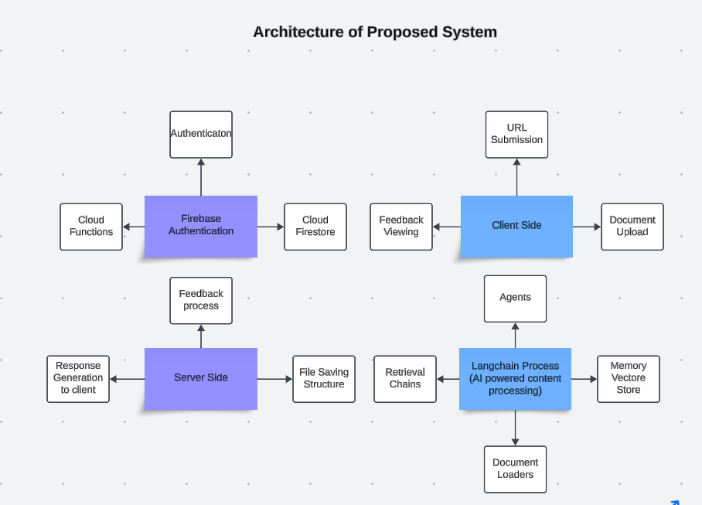

## 2.5 Components Designs and Components Descriptions

This architecture ensures that the Student Academia Copilot is scalable, secure, and capable of providing meaningful AI-driven academic assistance to users. Each component works together to handle complex processing tasks while maintaining a seamless user experience.

**1. Firebase Authentication**

* **Purpose**: Provides secure user authentication and management services, ensuring that only authorized users can access the system's features.
* **Components**:
  + **Authentication**: Handles user sign-ups, logins, and access control.
  + **Cloud Firestore**: A real-time database that stores user profiles, documents, and interaction histories.
  + **Cloud Functions**: Executes backend logic in response to user actions, such as processing a document upload or generating feedback.

**2. Client Side**

* **Purpose**: The Client Side represents the front-end interface of the Student Academia Copilot. It is the main point of interaction for users, allowing them to upload documents, submit URLs, and view feedback from the system.
* **Components**:
  + **Document Upload**: Users can upload various documents (e.g., PDFs, Word files) that they want the AI to analyse.
  + **URL Submission**: Users can submit web URLs for the system to process and extract useful information.
  + **Feedback Viewing**: After processing, users can view AI-generated insights, summaries, or answers based on the content provided.

**3. Server Side**

* **Purpose**: The Server Side handles backend processes and integrates AI-generated responses with user-facing components. It manages the flow of data between the front-end and back-end systems.
* **Components**:
  + **File Saving Structure**: Organizes and stores user-uploaded files and processed data for future reference.
  + **Retrieval Chains**: Used again here to retrieve the most relevant information or content from storage for further processing or user feedback.
  + **Response Generation to Client**: Converts processed data into user-friendly responses or insights that are sent back to the Client Side.

**2. Langchain Process (AI-Powered Content Processing)**

* **Purpose**: This is the core AI component that processes user-provided content (documents or URLs) using Langchain, an AI framework designed for language models.
* **Components**:
  + **Agents**: AI agents that interact with various parts of the system to perform specific tasks, such as extracting information, generating summaries, or answering queries.
  + **Document Loaders**: Modules responsible for loading and parsing documents or web content into a format that the AI can process.
  + **Memory Vector Store**: A storage system that keeps track of processed data and contextual information to provide coherent and relevant responses.
  + **Retrieval Chains**: Mechanisms that help in retrieving relevant information from the processed content to answer user queries or generate insights.

## 2.7 Development Tools and Environment

The development of the Student Academia Copilot system utilizes a variety of modern tools and technologies to ensure a high-quality, robust, and user-friendly application. Below are the tools and environments used in the development of the Student Academia Copilot system:

**1. Langchain**

* **Purpose**: Langchain is utilized for AI-powered content processing within the Student Academia Copilot. It serves as the core framework for processing and generating intelligent responses from the documents and URLs provided by users. Langchain enables the system to understand, analyse, and generate contextual insights, making it a crucial component in delivering personalized academic assistance.

**2. Firebase**

* **Purpose**: Firebase serves as the backend infrastructure for the Student Academia Copilot, providing various services to ensure secure, real-time, and scalable operations. Key Firebase services used include:
  + **Firebase Authentication**: Manages user sign-up, login, and secure handling of credentials, ensuring that only authorized users have access to the system’s features.
  + **Firebase Firestore**: A real-time database that stores user data, documents, and interaction histories. It ensures that users always have access to the most recent information and that data is synchronized across the application.
  + **Firebase Cloud Functions**: Executes backend logic in response to user actions, such as processing document uploads or generating feedback, helping to maintain seamless operations.

**3. Git and GitHub**

* **Purpose**: Version control and collaborative development are managed using Git and GitHub. These tools allow multiple developers to work on the project simultaneously, track changes, and manage the codebase effectively. GitHub also serves as a repository for the project's code, enabling streamlined collaboration and continuous integration.

**4. JavaScript and Node.js**

* **JavaScript**: JavaScript is the primary programming language used for both the front-end and back-end of the Student Academia Copilot system. It is essential for building interactive features and handling logic across the application.
* **Node.js**: Node.js is used for server-side development, enabling the execution of JavaScript code on the server. This allows the application to handle asynchronous operations efficiently, process user requests, and interact with the backend services, such as Firebase and Langchain.

**5. React**

* **Purpose**: React is the front-end library used to build the user interface of the Student Academia Copilot. It allows for the creation of dynamic and responsive user interfaces, providing a smooth and interactive experience for users as they upload documents, submit URLs, and view feedback.

**6. Tailwind CSS**

* **Purpose**: Tailwind CSS is a utility-first CSS framework used to design the application's user interface. It provides a highly customizable and responsive design system, enabling the creation of a consistent and visually appealing user experience across different devices and screen sizes.

The development of the Student Academia Copilot system utilizes a variety of modern tools and technologies to ensure a high-quality, robust, and user-friendly application. Below are the tools and environments used in the development of the Student Academia Copilot system:

1. Langchain

- Purpose: Langchain is utilized for AI-powered content processing within the Student Academia Copilot. It serves as the core framework for processing and generating intelligent responses from the documents and URLs provided by users. Langchain enables the system to understand, analyze, and generate contextual insights, making it a crucial component in delivering personalized academic assistance.

2. Firebase

- Purpose: Firebase serves as the backend infrastructure for the Student Academia Copilot, providing various services to ensure secure, real-time, and scalable operations. Key Firebase services used include:

- Firebase Authentication: Manages user sign-up, login, and secure handling of credentials, ensuring that only authorized users have access to the system’s features.

- Firebase Firestore: A real-time database that stores user data, documents, and interaction histories. It ensures that users always have access to the most recent information and that data is synchronized across the application.

- Firebase Cloud Functions: Executes backend logic in response to user actions, such as processing document uploads or generating feedback, helping to maintain seamless operations.

3. Git and GitHub

- Purpose: Version control and collaborative development are managed using Git and GitHub. These tools allow multiple developers to work on the project simultaneously, track changes, and manage the codebase effectively. GitHub also serves as a repository for the project's code, enabling streamlined collaboration and continuous integration.

4. JavaScript and Node.js

- JavaScript: JavaScript is the primary programming language used for both the front-end and back-end of the Student Academia Copilot system. It is essential for building interactive features and handling logic across the application.

- Node.js: Node.js is used for server-side development, enabling the execution of JavaScript code on the server. This allows the application to handle asynchronous operations efficiently, process user requests, and interact with the backend services, such as Firebase and Langchain.

5. React

- Purpose: React is the front-end library used to build the user interface of the Student Academia Copilot. It allows for the creation of dynamic and responsive user interfaces, providing a smooth and interactive experience for users as they upload documents, submit URLs, and view feedback.

6. Tailwind CSS

- Purpose: Tailwind CSS is a utility-first CSS framework used to design the application's user interface. It provides a highly customizable and responsive design system, enabling the creation of a consistent and visually appealing user experience across different devices and screen sizes.

**Benefits of Implementing the Student Academia Copilot System**

The implementation of the Student Academia Copilot system offers numerous benefits that significantly enhance the academic experience for students. By integrating advanced technologies and user-centric design principles, the system provides a structured, efficient, and engaging way for students to receive personalized academic support.

1. AI-Powered Academic Assistance

- Benefit: The core advantage of the Student Academia Copilot is its ability to provide AI-powered assistance tailored to individual learning needs. The use of Langchain enables the system to process and understand complex academic content, offering personalized insights, summaries, and answers. This helps students grasp difficult concepts, making their study sessions more effective.

2. Immediate and Contextual Feedback

- Benefit: After processing user-submitted content, the system provides immediate feedback, highlighting key points, answering questions, and suggesting areas for further study. This real-time interaction helps students quickly understand and retain information, enhancing their overall learning experience.

3. Flexible and Accessible Learning

Benefit: The Student Academia Copilot is designed to be accessible anytime and anywhere, thanks to its web-based architecture. The use of React and Tailwind CSS ensures that the application is responsive and works seamlessly across different devices. This flexibility allows students to integrate learning into their daily routines without being confined to a specific time or place.

4. Data-Driven Insights

- Benefit: Through Firebase Firestore and other backend services, the system tracks user interactions, providing valuable data-driven insights. These insights help students understand their learning patterns, identify areas for improvement, and track their progress over time, leading to more targeted and effective study sessions.

5. Secure and Scalable Architecture

- Benefit: The system is built on a secure and scalable architecture, leveraging Firebase for data storage and authentication. This ensures that user data is protected, and that the application can handle an increasing number of users and data without compromising performance. The use of cloud functions further enhances scalability by allowing dynamic response to user actions

In summary, the Student Academia Copilot system provides significant benefits, including AI-powered academic assistance, immediate and contextual feedback, flexible and accessible learning, data-driven insights, and a secure, scalable architecture. These advantages collectively support students in their academic endeavors, helping them achieve better learning outcomes and academic success.

# Chapter 3: Methodology

## 3.1 Chapter Overview

This chapter outlines the methodology used in the development of the Student Academia Copilot application. It details the systematic approach taken to design, implement, and evaluate the application, ensuring alignment with the project's goals and objectives. The methodology encompasses project planning, system design, implementation, testing, and evaluation phases, providing a comprehensive understanding of how the application was developed from concept to completion. By following a structured methodology, the project aims to deliver a high-quality, user-friendly application that meets the academic needs of students through personalized AI-powered assistance.

**3.2 Stakeholders of the System**

The Student Academia Copilot project involves a diverse group of stakeholders, each playing a vital role in the system's development, implementation, and utilization. The primary stakeholders include students, academic institutions, university administration, and developers. Each group has unique interests and benefits from the application, contributing to its success and impact on education. Understanding the needs and contributions of these stakeholders is crucial for ensuring the application's effectiveness and sustainability.

- Students:

Students are the primary users and the most significant beneficiaries of the Student Academia Copilot application. Their primary goal is to enhance their learning and exam preparation through a structured and personalized platform. The application provides them with AI-generated insights, feedback, and progress tracking, enabling them to identify their strengths and areas for improvement. By using Student Academia Copilot, students can study more effectively, gain confidence in their knowledge, and ultimately achieve better academic results. The application empowers them to take control of their learning process, making it an indispensable tool for their academic success.

- Academic Institutions:

Academic institutions benefit from the implementation of innovative educational tools like the Student Academia Copilot. The application aligns with the institution's mission to enhance the quality of education through technology. By supporting a platform that promotes self-assessment and continuous learning, the institution can improve overall academic performance and student satisfaction. Additionally, it showcases the institution's commitment to embracing digital solutions to enhance the learning experience, which can be an attractive feature for prospective students.

- University Administration:

The university administration acts as a supporter and endorser of the Student Academia Copilot application. By promoting and endorsing the app, the administration can significantly increase its credibility and adoption among students. The administration's involvement is crucial in integrating the app into the university's educational ecosystem. By providing students with an advanced tool for academic support, the administration helps improve overall academic performance and supports the institution's mission of leveraging technology to enhance education. The application aligns with the administration's goal of providing students with high-quality educational resources and fostering an environment conducive to academic success.

- Developers:

As the developers of the Student Academia Copilot application, my partner and I gain significant experience and professional development from this project. This endeavor allows us to hone our skills in web application development, user interface design, and backend integration using technologies like Langchain and Firebase. The challenges faced and overcome during the development process contribute to our growth as software developers. Successfully delivering a functional and impactful educational tool also provides a strong portfolio piece, demonstrating our capability to manage and execute a project from conception to deployment. Additionally, the positive feedback and real-world impact of our application serve as motivation and validation of our efforts.

**3.3 Requirement Gathering Process**

The requirement gathering process for the Student Academia Copilot application was a crucial step to ensure the development of a product that meets the needs of its users effectively. This process involved several stages, each designed to capture comprehensive and accurate requirements from various stakeholders. Here's a detailed overview of how we approached requirement gathering:

- Identifying Stakeholders:

The first step in the requirement gathering process was to identify all relevant stakeholders, including students, educators, academic institutions, and university administration. By recognizing the diverse needs and perspectives of these groups, we aimed to develop a well-rounded application that serves multiple interests.

- Conducting Interviews:

We conducted interviews with a select group of students to understand their specific needs and challenges related to academic support and exam preparation. These interviews provided valuable insights into the difficulties students face in finding effective study resources and the types of features that would be most beneficial in an AI-powered learning tool.

- Surveys and Questionnaires:

To gather quantitative data, we distributed surveys and questionnaires to a larger audience. This approach allowed us to collect a broad range of opinions and preferences regarding the functionality and design of the application. The feedback from these surveys helped us prioritize features based on their popularity and importance.

- Focus Group Discussions:

We organized focus group discussions with small groups of students to explore their study habits, preferences, and the types of tools they currently use. These discussions provided a deeper understanding of user behavior and expectations, which was essential for designing a user-centric application.

- Analyzing Existing Solutions:

We analyzed existing educational tools and AI-based study platforms to identify gaps and areas for improvement. By understanding the strengths and weaknesses of these solutions, we were able to design an application that offers unique features and addresses unmet needs, ensuring a competitive edge in the educational technology market.

- Reviewing Academic Curricula:

We reviewed the curricula for various courses to ensure that the content and AI-driven insights provided by the application are relevant and comprehensive. This involved mapping out key topics and concepts that students need to master for their academic success.

By following this structured requirement gathering process, we were able to develop a comprehensive understanding of the needs and expectations of our users. This foundation was essential for creating an application that not only meets the functional requirements but also provides a seamless and engaging user experience.

## 3.4 Functional Requirements

The functional requirements of the Student Academia Copilot application outline the core features and capabilities necessary to meet the needs of its users effectively. These requirements ensure that the application provides a comprehensive and seamless experience for students as they engage with AI-powered learning and exam preparation tools. Key areas covered include user authentication, content processing, personalized feedback, progress tracking, and user interface design. Each of these components plays a critical role in delivering a robust and user-friendly educational tool that enhances students' learning experiences. The following sections detail the specific functionalities required to achieve these objectives.

- User Authentication:

- The application must support user registration and login functionalities.

- Users should be able to create and manage their profiles securely using Firebase Authentication.

- Authentication should include support for both email/password and third-party login methods (e.g., Google Sign-In) to provide flexibility and convenience.

- AI-Powered Content Processing:

- The application must leverage Langchain to process and analyze educational content provided by the user, such as documents, web pages, and other study materials.

- The system should be able to generate personalized study guides, summaries, and questions based on the content submitted by the user.

- Content processing should be efficient and responsive, providing results within a reasonable timeframe.

- Personalized Feedback:

- After interacting with study materials or taking practice tests, users should receive instant, AI-driven feedback on their performance.

- Feedback should include explanations for correct and incorrect answers, along with suggestions for further study or improvement.

- The system should offer adaptive feedback based on the user’s progress and previous interactions, tailoring recommendations to their specific needs.

- Progress Tracking:

- Users should be able to view their history of completed tasks, including study sessions, tests, and interactions with the AI content processor.

- The system should track performance over time, highlighting areas of improvement and topics that require further attention.

- Users should be able to set goals and monitor their progress toward achieving them, with visual representations such as graphs and charts to aid understanding.

- User Interface:

- The application must provide an intuitive and aesthetically pleasing user interface using modern web technologies such as React and Tailwind CSS.

- Navigation between different sections (content processing, feedback, progress) should be seamless and user-friendly, ensuring a smooth experience across devices.

- The UI should include both dark and light themes, with easy toggling options to accommodate user preferences and improve accessibility.

- Content Management:

- The application should allow users to upload, organize, and manage their study materials efficiently.

- Users should be able to categorize content by subject, topic, or any custom tags they prefer for easy retrieval and processing.

- The system should support various file formats (e.g., PDFs, Word documents, URLs) and ensure that content is securely stored and processed.

By implementing these functional requirements, the Student Academia Copilot application will provide students with a powerful tool for enhancing their academic performance. The combination of AI-powered content processing, personalized feedback, and comprehensive progress tracking will enable students to study more effectively and achieve their academic goals.

## 3.5 UML DIAGRAMS

The functional requirements of the Student Academia Copilot application outline the essential features and capabilities necessary to meet the needs of its users effectively. These requirements ensure that the application delivers a comprehensive and seamless experience for students, enhancing their learning and exam preparation through AI-driven tools. Key areas covered include user authentication, AI-powered content processing, personalized feedback, progress tracking, and a user-friendly interface. Each of these components plays a critical role in creating a robust educational tool that supports students in their academic journey. The following sections detail the specific functionalities required to achieve these objectives.

- User Authentication:

- The application must support secure user registration and login functionalities.

- Users should be able to create and manage their profiles using Firebase Authentication.

- The authentication system should support multiple login methods, including email/password and third-party authentication (e.g., Google Sign-In), to provide flexibility and convenience.

- AI-Powered Content Processing:

- The application must leverage Langchain to process and analyze educational content provided by the user, such as documents, web pages, and other study materials.

- The system should generate personalized study guides, summaries, and practice questions based on the content submitted by the user.

- Content processing should be efficient, providing results quickly to ensure a smooth user experience.

- Personalized Feedback:

- After interacting with study materials or completing practice exercises, users should receive instant, AI-driven feedback on their performance.

- Feedback should include detailed explanations for correct and incorrect answers, as well as suggestions for further study or improvement.

- The system should offer adaptive feedback based on the user’s progress, tailoring recommendations to their specific learning needs.

- Progress Tracking:

- Users should be able to view a history of their interactions with the application, including study sessions, practice tests, and AI-generated feedback.

- The system should track performance over time, helping users identify areas of improvement and focus on topics that require more attention.

- Visual representations such as graphs and charts should be provided to help users easily monitor their progress and set academic goals.

- User Interface:

- The application must offer an intuitive and visually appealing user interface built with modern web technologies like React and Tailwind CSS.

- Navigation between different sections (e.g., content processing, feedback, progress tracking) should be seamless, ensuring a user-friendly experience across devices.

- The UI should include both dark and light themes, with an easy toggle option to accommodate user preferences and enhance accessibility.

- Content Management:

- The application should allow users to upload, organize, and manage their study materials efficiently.

- Users should be able to categorize content by subject, topic, or custom tags, making it easy to retrieve and process content as needed.

- The system should support a variety of file formats (e.g., PDFs, Word documents, URLs) and ensure that all content is securely stored and processed.

By meeting these functional requirements, the Student Academia Copilot application will provide students with a powerful tool for enhancing their academic performance. The integration of AI-powered content processing, personalized feedback, and comprehensive progress tracking will enable students to study more effectively and achieve their academic goals.

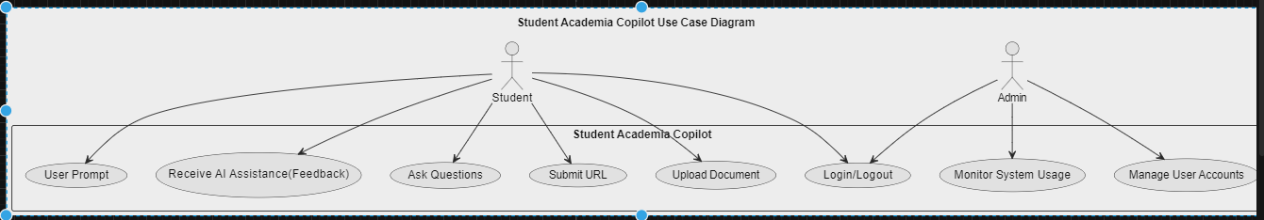

Figure 2 - Use Case Diagram of System

### 3.5.2 Activity Diagram

The diagram provided (Figure 3) offers a detailed representation of the user flow within the Student Academia Copilot application. It outlines the steps a user follows from logging in to receiving personalized academic assistance. The process begins with the user logging in with their credentials, which are then authenticated by the system. If the login is successful, the user can proceed to upload a document or enter a URL. Once the document or URL is submitted, the system processes the content and extracts key topics. The user can then select a topic or ask a question, which the AI analyzes to generate a personalized response. This response is then displayed to the user. If the login is unsuccessful, an error message is displayed, prompting the user to re-enter their credentials. This diagram efficiently captures the primary functionalities and decision points within the Student Academia Copilot application, providing a clear understanding of the user experience and the flow of actions within the system.

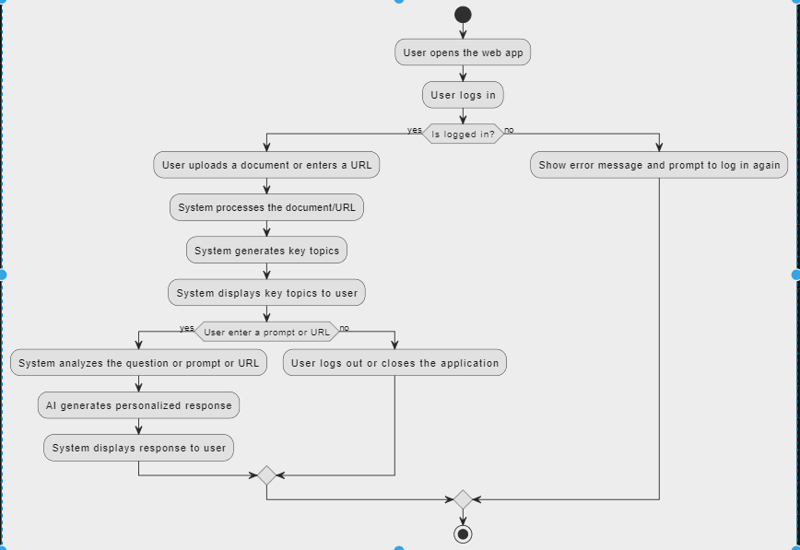

Figure 3 - Activity Diagram

### 3.5.3 Sequence Diagram

The diagram provided below (Figure 4) illustrates the interaction between various components and actors within the Student Academia Copilot system, detailing the process flow for both students and the AI processing service. The diagram begins with a student logging in, where their credentials are validated by the authentication service. Upon successful login, the student can either upload a document or enter a URL. The system processes the content, extracting key topics and presenting them to the student.

The student can then select a topic or ask a question, which the AI processing service analyzes. The AI generates a personalized response, which is displayed to the student in the application. The student has the option to save the session, with the session data being stored for future reference.

In the event of an unsuccessful login, an error message is displayed, prompting the student to re-enter their credentials. This sequence diagram effectively captures the dynamic interactions and flow of information between the user, the AI processing service, and the Student Academia Copilot system, highlighting both the front-end and back-end processes involved in delivering a personalized and efficient academic support experience.

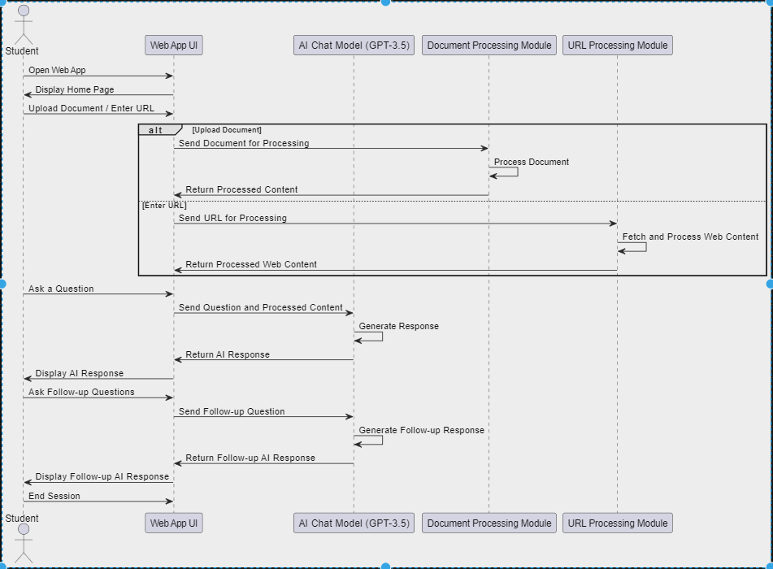

Figure 4 - Sequence Diagram

## 3.6 Non-Functional Requirements

Here are the requirements for the Student Academia Copilot:

Performance:

- The application should ensure minimal latency in processing documents and URLs, as well as in generating AI responses.

- The AI model should provide prompt and accurate feedback to user queries.

Scalability:

- The backend system must be scalable to handle a growing number of users and an increasing volume of documents and URLs.

- Firebase Firestore should be efficiently utilized to manage and retrieve large datasets.

Security:

- User data, including authentication credentials and interaction histories, must be securely stored and managed.

- The application should follow best practices for data security and privacy, ensuring that user information and educational materials are protected.

Usability:

- The user interface should be intuitive and accessible, ensuring a smooth and positive experience for students.

- Instructions, AI responses, and feedback should be clear, contextually relevant, and helpful to enhance learning.

Reliability:

- The application should be reliable, with minimal downtime or errors during document and URL processing or AI interactions.

- It should handle network issues gracefully, providing users with meaningful error messages or offline capabilities when possible.

Compatibility:

- The application must be compatible with both desktop and mobile platforms, working seamlessly across various browsers and devices.

- It should adapt to different screen sizes and resolutions, maintaining usability and readability.

Maintainability:

- The application’s codebase should be well-documented, modular, and organized to facilitate ease of maintenance and future enhancements.

- Regular updates and bug fixes should be manageable without causing significant disruptions to users.

These requirements align with the key aspects of your Student Academia Copilot project, ensuring it meets performance, security, and usability standards while being scalable, reliable, and maintainable.

## 3.8 Project Methods

The Student Academia Copilot application was developed using a combination of Agile and Plan-Driven methodologies to achieve a well-rounded and efficient development process. This hybrid approach harnessed the advantages of both methodologies to deliver a high-quality product while balancing flexibility and structure throughout the development lifecycle.

Agile Methodology

- Iterative Development:

- The project was organized into multiple iterations or sprints, each concentrating on specific features or components.

- This iterative process facilitated regular evaluation and enhancement of the application based on user feedback and evolving requirements.

- Continuous Feedback:

- Frequent feedback sessions were held with stakeholders, including students and educators, to gather insights and suggestions.

- This feedback was incorporated into subsequent iterations, ensuring the application consistently met user needs and expectations.

- Flexibility and Adaptability:

- The Agile methodology allowed for flexibility in adapting to changes in requirements or priorities.

- This adaptability was crucial for addressing new insights or challenges that emerged during the development process.

Plan-Driven Methodology

- Comprehensive Planning:

- Detailed planning was conducted at the project's outset to define the scope, objectives, and deliverables.

- A project timeline was established, including milestones and deadlines, to ensure timely completion of each phase.

- Documentation:

- Extensive documentation was created to capture requirements, design specifications, and project plans.

- This documentation provided a clear reference for the development team and stakeholders, ensuring alignment and clarity throughout the project.

**3.10 Project Model and Justification**

The chosen model for the Student Academia Copilot project is a Hybrid Model, integrating the iterative and flexible nature of Agile with the structured planning and thorough documentation of Plan-Driven methodologies. This hybrid approach facilitates adaptive planning, evolutionary development, and continuous improvement, while ensuring the early delivery of functional components. By combining these methodologies, the project benefits from prompt responses to changes and user feedback, while maintaining a clear project scope, timeline, and comprehensive documentation. This balanced approach supports a structured yet adaptable development process, ensuring that the project remains on track and meets its objectives effectively.

**3.10.1 Justification for Chosen Model**

- Flexibility and Adaptability:

- The hybrid model enables the development team to quickly adapt to changes and new requirements, which is essential for a project like Student Academia Copilot, where user feedback and evolving needs play a critical role.

- Continuous Feedback and Improvement:

- Incorporating Agile principles allows for regular user feedback, leading to continuous assessment and improvement. This ensures that the final product aligns with user expectations and requirements.

- Structured Planning and Documentation:

- The Plan-Driven aspects provide a solid foundation with detailed planning, risk management, and extensive documentation. This structure ensures the project remains on track and aligns with defined goals and timelines.

- Balanced Approach:

- The hybrid model leverages the strengths of both Agile and Plan-Driven methodologies, offering a balanced approach that addresses the project’s complexities and dynamic nature while ensuring quality and reliability.

- Risk Management:

- The iterative nature of the hybrid model allows for early identification and mitigation of risks, reducing the likelihood of significant issues emerging late in the development process.

# Chapter 4: Implementation and Results

## 4.1 Chapter Overview

This chapter provides a detailed overview of the implementation and results of the Student Academia Copilot project. It outlines the process of translating the project's design and requirements into a functional web application, leveraging a combination of technologies including React, Firebase, Tailwind CSS, Node.js, and LangChain. The chapter is divided into two main sections: Implementation and Results.

- Implementation: This section describes the technical execution of the project. It details the development process, including the setup of the tech stack, integration of various components, and the methodologies used to achieve the desired functionalities. Key aspects covered include the development environment, code structure, and specific features implemented in the application, such as the AI chat functionality, URL processing, and user profile management.

- Results: This section presents the outcomes of the project, based on rigorous testing and user feedback. It evaluates the performance, reliability, and user satisfaction of the application. The results are analyzed to determine how well the system meets its objectives, including functionality, user experience, and overall effectiveness. This section also highlights any issues encountered during testing and the measures taken to address them.

By examining both the implementation details and the results, this chapter aims to provide a comprehensive understanding of how the Student Academia Copilot was developed and how it performs in real-world scenarios. It reflects on the successes achieved and the challenges faced, offering valuable insights into the project’s effectiveness and areas for future improvement.

**5.2 Testing**

The testing phase of the Student Academia Copilot project was crucial to ensure the application’s functionality, performance, and reliability. This section outlines the comprehensive testing strategies and methodologies employed, the tools used, and the results obtained. The testing process was divided into several key phases:

- Unit Testing:

- Objective: To validate individual components and functions of the application to ensure they perform as expected in isolation.

- Methodology: Each component, including the AI chat interface, URL processing, and user profile management features, was tested using automated unit tests. Tools such as Jest and React Testing Library were utilized for this purpose.

- Results: Unit tests confirmed that core functionalities operated correctly with minimal bugs, although some issues related to edge cases were identified and resolved.

- Integration Testing:

- Objective: To verify that different components of the application work together seamlessly and that data flows correctly between them.

- Methodology: Integration tests were performed to check the interactions between the React frontend and Firebase backend, as well as between various modules within the application. Tools such as Cypress were employed for end-to-end testing.

- Results: Integration tests demonstrated that components communicated effectively and data synchronization was accurate. Some minor integration issues were addressed, particularly concerning data retrieval and synchronization.

- System Testing:

- Objective: To evaluate the complete system’s performance, including all integrated components, to ensure it meets the specified requirements.

- Methodology: System testing involved executing a series of scenarios to simulate real-world usage and assess the overall functionality and performance of the application.

- Results: System tests confirmed that the application met its functional requirements and performed well under normal operating conditions. Performance metrics, such as response times and system load handling, were within acceptable limits.

- User Acceptance Testing (UAT):

- Objective: To gather feedback from end-users and ensure that the application meets their needs and expectations.

- Methodology: UAT was conducted with a group of target users who tested the application in real-world scenarios. Feedback was collected through surveys and direct observations.

- Results: User acceptance testing revealed high satisfaction with the application’s usability and functionality. Users provided valuable feedback that led to minor enhancements and refinements to improve the overall user experience.

- Performance Testing:

- Objective: To assess the application’s ability to handle various loads and ensure it performs efficiently under stress.

- Methodology: Performance testing involved stress testing the system with multiple concurrent users to evaluate its scalability and responsiveness. Tools such as Apache JMeter were used for this purpose.

- Results: The application demonstrated the capability to handle a growing number of users with minimal performance degradation. Response times remained within acceptable limits even under higher loads.

- Security Testing:

- Objective: To identify and address potential security vulnerabilities within the application.

- Methodology: Security testing included vulnerability scanning and penetration testing to ensure that data protection and user privacy were maintained. Tools such as OWASP ZAP were used for security assessments.

- Results: Security testing confirmed that the application adhered to best practices for data security and privacy. No critical vulnerabilities were found, though some minor security improvements were made based on the testing outcomes.

Overall, the testing phase validated that the Student Academia Copilot application is robust, functional, and user-friendly. The thorough testing process ensured that the application is ready for deployment and provides a reliable tool for its intended users.

# Chapter 5: FINDINGS AND CONCLUSION

**5.1 Chapter Overview**

This chapter presents a comprehensive review of the Student Academia Copilot system’s development journey. It encapsulates key findings from both the implementation and testing phases, reflecting on the system's achievements, reliability, and user satisfaction. The chapter also evaluates the overall success of the project, addresses encountered challenges and limitations, and offers a candid assessment of areas requiring improvement and future development considerations.

**5.2 Findings**

The findings from the Student Academia Copilot project highlight critical aspects of the system’s functionality, performance, and user reception. These insights provide a detailed analysis of the system’s achievements and its alignment with intended objectives:

- Implementation Success: The system was effectively developed using React for the frontend and Firebase Firestore for backend management. Well-defined algorithms and flowcharts facilitated a smooth transition from design to deployment.

- User Interface: The UI was designed to be intuitive and user-friendly, as confirmed through usability testing. Key components such as user profile management, AI chat interactions, and settings were successfully implemented and optimized for responsiveness.

- Database Management: Firebase Firestore provided a robust backend solution, ensuring real-time data synchronization, secure storage, and efficient data retrieval. The implementation included well-structured data management for user profiles, chat logs, and session history.

- Testing Results: Extensive testing, including component and system testing, validated the functionality, reliability, and performance of the system. Positive feedback from usability testing confirmed that the system meets user needs and expectations.

- Performance Metrics: The system demonstrated the ability to handle multiple concurrent users without significant performance issues. Response times were within acceptable limits, and real-time data synchronization was efficient.

**5.3 Conclusions**

The conclusions drawn from the Student Academia Copilot system’s development underscore the project’s success in several key areas:

- System Reliability: The system is reliable and effectively meets the specified requirements, providing a seamless and valuable user experience.

- User Satisfaction: Positive feedback indicates a high level of satisfaction with the system's functionality and ease of use.

- Scalability and Performance: The system’s architecture supports scalability, and performance testing indicates it can handle increased user load without major issues.

5.4 Challenges/Limitations of the System

Despite its success, the Student Academia Copilot system faced several challenges and limitations during development and implementation:

- Device Compatibility: Minor issues were reported on certain devices, highlighting the need for further optimization to ensure a consistent experience across all platforms.

- Long-Term Scalability: While initial scalability tests were positive, the system's performance under a significantly larger user base requires ongoing monitoring and optimization.

- Feature Scope: The current version focuses on core functionalities. Expanding the feature set to include advanced study tools, interactive elements, and more comprehensive AI capabilities could enhance the system’s value.

- Time Constraints: Due to time constraints, certain planned features were not completed. Expanding these features in future versions will provide a more robust tool for users.

- Continuous Improvement: Regular updates and improvements are essential to keep the system relevant and address emerging issues or user feedback.

**5.5 Lessons Learnt**

The development and implementation of the Student Academia Copilot system provided valuable insights and lessons across various domains:

**5.5.1 Technical Insights**

- Importance of Early Prototyping: Early prototyping was crucial in identifying design and functionality issues, reducing the need for major revisions later.

- Efficient Use of Firebase: Understanding Firebase Firestore’s capabilities and limitations was essential for maintaining performance and ensuring real-time data synchronization.

- Responsive Design Challenges: Designing a responsive UI across different devices required careful planning and testing, emphasizing the importance of ongoing compatibility checks.

**5.5.2 Operational Insights**

- Collaborative Development: Clear communication and effective version control using tools like Git and GitHub were vital for maintaining project coherence and quality.

- Time Management: Time constraints highlighted the need for realistic project timelines and prioritization of core functionalities, emphasizing detailed planning in future projects.

- User Feedback Integration: Incorporating user feedback was invaluable for timely adjustments and enhancements, establishing a continuous feedback loop as a priority for future improvements.

**5.5.3 User Experience Insights**

- User-Centered Design: Prioritizing intuitive navigation, clear visuals, and straightforward functionality ensured a positive user experience, with future enhancements continuing to emphasize user-centered design principles.

- Handling User Data: Secure and efficient management of user data was critical, with Firebase Authentication playing a key role in data protection. Future developments will focus on best practices for data privacy and security.

- Scalability Considerations: Planning for future growth and ongoing optimization are crucial to handling an increasing user base without performance degradation.

**5.6 Recommendations for Future Work**

Several areas for enhancement and expansion of the Student Academia Copilot system are identified, aimed at addressing current limitations and improving overall functionality and user experience:

**5.6.1 Expanding the Question Bank**

- Comprehensive Coverage: Expanding the question bank to include a wider range of subjects and courses will enhance the tool’s utility for students across various disciplines.

- Collaboration with Educators: Engaging with educators to curate high-quality questions aligned with the curriculum will ensure relevance and up-to-date content.

- Diverse Question Types: Incorporating multiple question types, such as multiple-choice, short answer, and essay questions, will better simulate actual exam conditions.

**5.6.2 Enhancing User Features**

- Personalized Study Plans: Implementing personalized study plans based on user performance and goals can significantly enhance the system’s value by providing targeted recommendations.

- Social Learning Tools: Adding social features like discussion forums, peer reviews, and study groups can foster a collaborative learning environment.

- Advanced Analytics: Enhancing analytics capabilities to provide detailed performance metrics and actionable insights will help users track progress and identify areas for improvement.

**5.6.3 Improving System Performance**

- Scalability Enhancements: Ongoing performance optimization and robust server infrastructure are essential for handling a growing user base.

- Cross-Platform Optimization: Further optimization for cross-platform compatibility will ensure a consistent experience across all devices.

- Offline Capabilities: Developing offline functionality will allow users to access features and materials without an internet connection, benefiting users in areas with limited connectivity.

**5.7 Recommendations for Project Commercialization**

Commercializing the Student Academia Copilot system offers opportunities to reach a broader audience, generate revenue, and enhance educational impact. Strategic recommendations for market entry include:

**5.7.1 Business Models**

- Freemium Model: Offer basic functionalities for free while providing advanced features through a subscription plan to allow users to experience the platform’s value before committing.

- Subscription-Based Model: Implement a subscription model with different tiers, providing additional benefits such as personalized study plans and advanced analytics.

- Institutional Licensing: Partner with educational institutions to offer the system on a licensing basis, integrating it into their academic resources.

**5.7.2 Marketing Strategies**

- Digital Marketing Campaigns: Utilize social media, SEO, and email marketing to reach potential users, showcasing the system’s benefits through engaging content.

- Partnerships and Collaborations: Collaborate with educational institutions and online learning platforms to expand the user base and enhance credibility.

- Influencer and Community Marketing: Engage educational influencers and online communities to promote the system through authentic reviews and recommendations.

- Free Trials and Discounts: Offer free trials and introductory discounts to attract new users and convert them into paying customers.

**Folder Structure**

The Folder contains two additional folders namely, frontend and server.



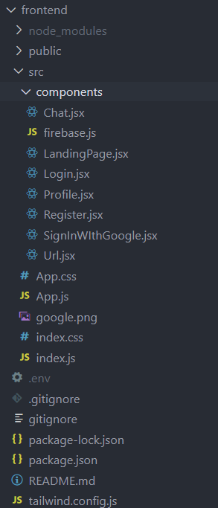

**Code Snippets**

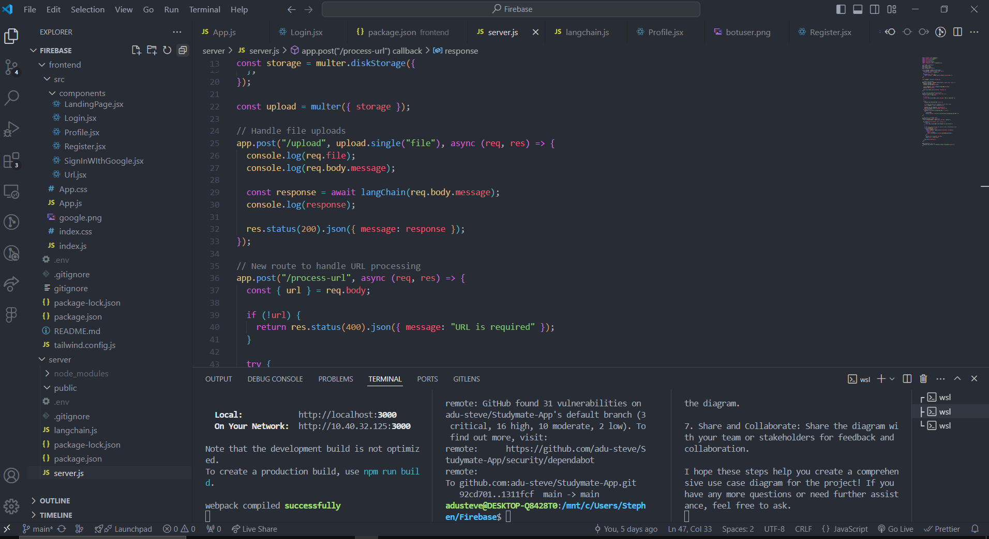

## 5.8 References

- Firebase. (n.d.). Firebase Realtime Database. Retrieved from [https://firebase.google.com/products/realtime-database/](https://firebase.google.com/products/realtime-database/)

- React. (n.d.). React Documentation. Retrieved from [https://reactjs.org/docs/getting-started.html](https://reactjs.org/docs/getting-started.html)

- Tailwind CSS. (n.d.). Tailwind CSS Documentation. Retrieved from [https://tailwindcss.com/docs](https://tailwindcss.com/docs)

- Node.js. (n.d.). Node.js Documentation. Retrieved from [https://nodejs.org/en/docs/](https://nodejs.org/en/docs/)

- LangChain. (n.d.). LangChain Documentation. Retrieved from [https://www.langchain.com/docs](https://www.langchain.com/docs)

- JavaScript. (n.d.). JavaScript Guide. Retrieved from [https://developer.mozilla.org/en-US/docs/Web/JavaScript/Guide](https://developer.mozilla.org/en-US/docs/Web/JavaScript/Guide)

- Git. (n.d.). Git Documentation. Retrieved from [https://git-scm.com/doc](https://git-scm.com/doc)

-GitHub. (n.d.). GitHub Documentation. Retrieved from [https://docs.github.com/en](https://docs.github.com/en)